 

# Lecture-6 Multiplexing & Circuit Switching

# What is Multiplexing?

Multiplexing is a technique used to combine and send the multiple data streams over a single medium. The process of combining the data streams is known as multiplexing and hardware used for multiplexing is known as a multiplexer.

Multiplexing is achieved by using a device called Multiplexer (**MUX**) that combines n input lines to generate a single output line. Multiplexing follows many-to-one, i.e., n input lines and one output line.

Demultiplexing is achieved by using a device called Demultiplexer (**DEMUX**) available at the receiving end. DEMUX separates a signal into its component signals (one input and n outputs). Therefore, we can say that demultiplexing follows the one-to-many approach.

## Why Multiplexing?

* The transmission medium is used to send the signal from sender to receiver. The medium can only have one signal at a time.
* If there are multiple signals to share one medium, then the medium must be divided in such a way that each signal is given some portion of the available bandwidth. For example: If there are 10 signals and bandwidth of medium is 100 units, then the 10 unit is shared by each signal.
* When multiple signals share the common medium, there is a possibility of collision. Multiplexing concept is used to avoid such collision.
* Transmission services are very expensive.

## History of Multiplexing

* Multiplexing technique is widely used in telecommunications in which several telephone calls are carried through a single wire.
* Multiplexing originated in telegraphy in the early 1870s and is now widely used in communication.
* George Owen Squier developed the **telephone carrier multiplexing** in 1910.

## Concept of Multiplexing

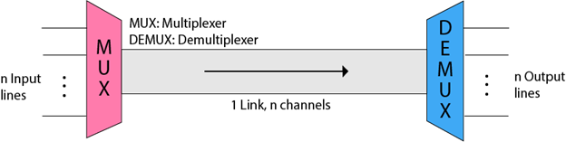

* The 'n' input lines are transmitted through a multiplexer and multiplexer combines the signals to form a composite signal.
* The composite signal is passed through a Demultiplexer and demultiplexer separates a signal to component signals and transfers them to their respective destinations.

## Advantages of Multiplexing:

* More than one signal can be sent over a single medium.
* The bandwidth of a medium can be utilized effectively.

# Multiplexing Techniques

Multiplexing techniques can be classified as:

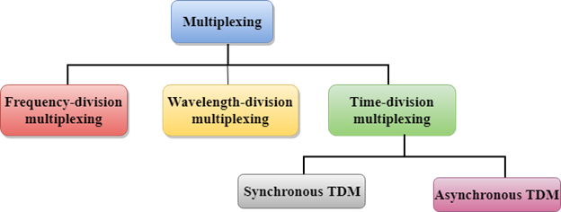

## Time Division Multiplexing

* It is a digital technique.
* In Frequency Division Multiplexing Technique, all signals operate at the same time with different frequency, but in case of Time Division Multiplexing technique, all signals operate at the same frequency with different time.
* In **Time Division Multiplexing technique**, the total time available in the channel is distributed among different users. Therefore, each user is allocated with different time interval known as a Time slot at which data is to be transmitted by the sender.
* A user takes control of the channel for a fixed amount of time.
* In Time Division Multiplexing technique, data is not transmitted simultaneously rather the data is transmitted one-by-one.
* In TDM, the signal is transmitted in the form of frames. Frames contain a cycle of time slots in which each frame contains one or more slots dedicated to each user.
* It can be used to multiplex both digital and analog signals but mainly used to multiplex digital signals.

**There are two types of TDM:**

* Synchronous TDM
* Asynchronous TDM

## Synchronous TDM

* A Synchronous TDM is a technique in which time slot is preassigned to every device.
* In Synchronous TDM, each device is given some time slot irrespective of the fact that the device contains the data or not.
* If the device does not have any data, then the slot will remain empty.
* In Synchronous TDM, signals are sent in the form of frames. Time slots are organized in the form of frames. If a device does not have data for a particular time slot, then the empty slot will be transmitted.
* The most popular Synchronous TDM are T-1 multiplexing, ISDN multiplexing, and SONET multiplexing.
* If there are n devices, then there are n slots.

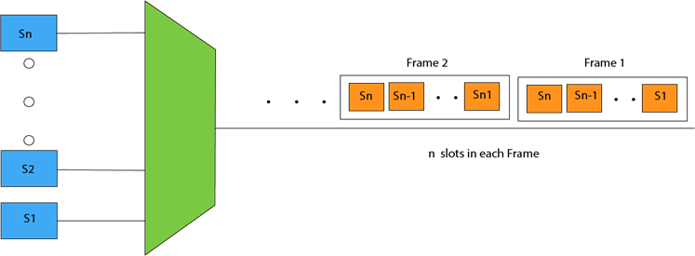

**Concept Of Synchronous TDM**

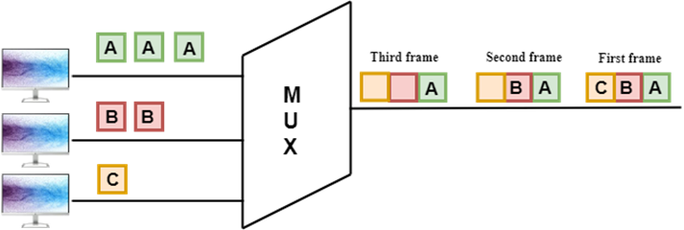

In the above figure, the Synchronous TDM technique is implemented. Each device is allocated with some time slot. The time slots are transmitted irrespective of whether the sender has data to send or not.

**Disadvantages Of Synchronous TDM:**

* The capacity of the channel is not fully utilized as the empty slots are also transmitted which is having no data. In the above figure, the first frame is completely filled, but in the last two frames, some slots are empty. Therefore, we can say that the capacity of the channel is not utilized efficiently.
* The speed of the transmission medium should be greater than the total speed of the input lines. An alternative approach to the Synchronous TDM is Asynchronous Time Division Multiplexing.

## Asynchronous TDM

* An asynchronous TDM is also known as Statistical TDM.
* An asynchronous TDM is a technique in which time slots are not fixed as in the case of Synchronous TDM. Time slots are allocated to only those devices which have the data to send. Therefore, we can say that Asynchronous Time Division multiplexor transmits only the data from active workstations.
* An asynchronous TDM technique dynamically allocates the time slots to the devices.
* In Asynchronous TDM, total speed of the input lines can be greater than the capacity of the channel.
* Asynchronous Time Division multiplexor accepts the incoming data streams and creates a frame that contains only data with no empty slots.
* In Asynchronous TDM, each slot contains an address part that identifies the source of the data.

Multiplexing Techniques

* The difference between Asynchronous TDM and Synchronous TDM is that many slots in Synchronous TDM are unutilized, but in Asynchronous TDM, slots are fully utilized. This leads to the smaller transmission time and efficient utilization of the capacity of the channel.
* In Synchronous TDM, if there are n sending devices, then there are n time slots. In Asynchronous TDM, if there are n sending devices, then there are m time slots where m is less than n (**m<n**).
* The number of slots in a frame depends on the statistical analysis of the number of input lines.

**Concept Of Asynchronous TDM**

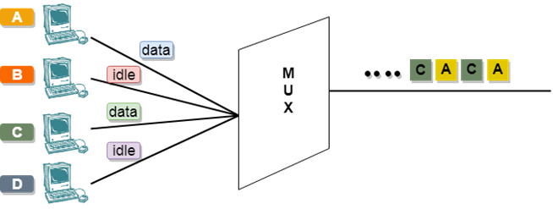

In the above diagram, there are 4 devices, but only two devices are sending the data, i.e., A and C. Therefore, the data of A and C are only transmitted through the transmission line.

**Frame of above diagram can be represented as:**

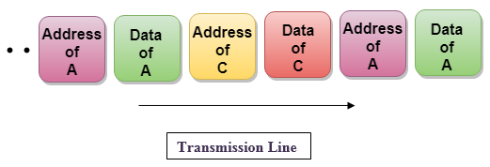

The above figure shows that the data part contains the address to determine the source of the data.

# Switching

* When a user accesses the internet or another computer network outside their immediate location, messages are sent through the network of transmission media. This technique of transferring the information from one computer network to another network is known as **switching**.
* Switching in a computer network is achieved by using switches. A switch is a small hardware device which is used to join multiple computers together with one local area network (LAN).
* Network switches operate at layer 2 (Data link layer) in the OSI model.
* Switching is transparent to the user and does not require any configuration in the home network.
* Switches are used to forward the packets based on MAC addresses.
* A Switch is used to transfer the data only to the device that has been addressed. It verifies the destination address to route the packet appropriately.
* It is operated in full duplex mode.
* Packet collision is minimum as it directly communicates between source and destination.
* It does not broadcast the message as it works with limited bandwidth.

## Why is Switching Concept required?

Switching concept is developed because of the following reasons:

* **Bandwidth:** It is defined as the maximum transfer rate of a cable. It is a very critical and expensive resource. Therefore, switching techniques are used for the effective utilization of the bandwidth of a network.
* **Collision:** Collision is the effect that occurs when more than one device transmits the message over the same physical media, and they collide with each other. To overcome this problem, switching technology is implemented so that packets do not collide with each other.

### Advantages of Switching:

* Switch increases the bandwidth of the network.
* It reduces the workload on individual PCs as it sends the information to only that device which has been addressed.
* It increases the overall performance of the network by reducing the traffic on the network.
* There will be less frame collision as switch creates the collision domain for each connection.

### Disadvantages of Switching:

* A Switch is more expensive than network bridges.
* A Switch cannot determine the network connectivity issues easily.
* Proper designing and configuration of the switch are required to handle multicast packets.

# Switching techniques

In large networks, there can be multiple paths from sender to receiver. The switching technique will decide the best route for data transmission.

Switching technique is used to connect the systems for making one-to-one communication.

**Classification Of Switching Techniques**

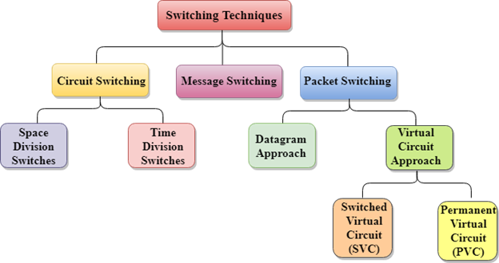

## Circuit Switching

* Circuit switching is a switching technique that establishes a dedicated path between sender and receiver.
* In the Circuit Switching Technique, once the connection is established then the dedicated path will remain to exist until the connection is terminated.
* Circuit switching in a network operates in a similar way as the telephone works.
* A complete end-to-end path must exist before the communication takes place.
* In case of circuit switching technique, when any user wants to send the data, voice, video, a request signal is sent to the receiver then the receiver sends back the acknowledgment to ensure the availability of the dedicated path. After receiving the acknowledgment, dedicated path transfers the data.
* Circuit switching is used in public telephone network. It is used for voice transmission.
* Fixed data can be transferred at a time in circuit switching technology.

**Communication through circuit switching has 3 phases:**

* Circuit establishment
* Data transfer
* Circuit Disconnect

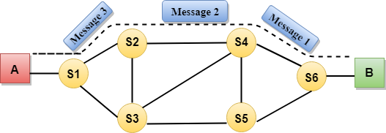

Circuit Switching can use either of the two technologies:

### Space Division Switches:

* Space Division Switching is a circuit switching technology in which a single transmission path is accomplished in a switch by using a physically separate set of crosspoints.
* Space Division Switching can be achieved by using crossbar switch. A crossbar switch is a metallic crosspoint or semiconductor gate that can be enabled or disabled by a control unit.
* The Crossbar switch is made by using the semiconductor. For example, Xilinx crossbar switch using Field Programmable Gate Arrays (FPGAs).
* Space Division Switching has high speed, high capacity, and nonblocking switches.

**Space Division Switches can be categorized in two ways:**

* **Crossbar Switch**
* **Multistage Switch**

### Crossbar Switch

The Crossbar switch is a switch that has n input lines and n output lines. The crossbar switch has n2 intersection points known as **crosspoints.**

**Disadvantage of Crossbar switch:**

The number of crosspoints increases as the number of stations is increased. Therefore, it becomes very expensive for a large switch. The solution to this is to use a multistage switch.

### Multistage Switch

* Multistage Switch is made by splitting the crossbar switch into the smaller units and then interconnecting them.
* It reduces the number of crosspoints.
* If one path fails, then there will be an availability of another path.

**Advantages Of Circuit Switching:**

* In the case of Circuit Switching technique, the communication channel is dedicated.
* It has fixed bandwidth.

**Disadvantages Of Circuit Switching:**

* Once the dedicated path is established, the only delay occurs in the speed of data transmission.
* It takes a long time to establish a connection approx 10 seconds during which no data can be transmitted.
* It is more expensive than other switching techniques as a dedicated path is required for each connection.
* It is inefficient to use because once the path is established and no data is transferred, then the capacity of the path is wasted.
* In this case, the connection is dedicated therefore no other data can be transferred even if the channel is free.

## Time Division Switching

Time division switching comes under digital switching techniques, where the Pulse Code Modulated signals are mostly present at the input and the output ports. A digital Switching system is one, where the inputs of any PCM highway can be connected to the outputs of any PCM highway, to establish a call.

The incoming and outgoing signals when received and re-transmitted in a different time slot, is called **Time Division Switching.** The digitized speech information is sliced into a sequence of time intervals or slots. Additional voice circuit slots, corresponding to other users are inserted into this bit stream of data. Hence, the data is sent in time frames.

The main difference between space division multiplexing and time division multiplexing is sharing of Crosspoints. Crosspoints are not shared in space division switching, whereas they can be shared in time division multiplexing, for shorter periods. This helps in reassigning the Crosspoints and its associated circuitry for other connections as well.

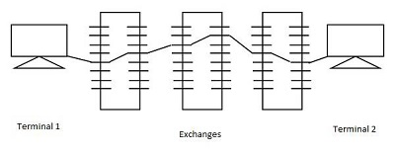

Time division switches use time division multiplexing, in switching. The two popular methods of TDM are TSI (Time and Slot Interchange) and TDM bus. The data sent at the transmitter reaches the receiver in the same order, in an ordinary time division multiplexing whereas, in TSI mechanism, the data sent is changed according to the ordering of slots based on the desired connections. It consists of RAM with several memory locations such as input, output locations and control unit.

Both of the techniques are used in digital transmission. The TDM bus utilizes multiplexing to place all the signals on a common transmission path. The bus must have higher data rate than individual I/O lines. The main advantage of time division multiplexing is that, there is no need of Crosspoints. However, processing each connection creates delay as each time slot must be stored by RAM, then retrieved and then passed on.